Exponential distribution

Intro

According to Wiki in Ref section,

Exponential distribution is a [probability distribution](https://en.wikipedia.org/wiki/Probability_distribution) of the time between events in a [Poisson point process](https://en.wikipedia.org/wiki/Poisson_point_process), i.e., a process in which events occur continuously and independently at a constant average rate. It is a particular case of the [gamma distribution](https://en.wikipedia.org/wiki/Gamma_distribution).

PDF

$$f\left(x;l\right)=le^{−lx}$$ if $$x≥0$$

$$f\left(x;l\right)=0$$ otherwise.

CDF

$$F\left(x;l\right)=1−e^{−lx}$$ if $$x≥0$$

$$F\left(x;l\right) = 0$$ otherwise

Expected Value

$$E\left[X\right]=\frac{1}{l}$$

Proof:

$$E\left[X\right]=integral\left(x\operatorname{Pr}\left(x\right)dx,x=−inf,x=\inf{}\right)$$

= $$integral\left(x\operatorname{Pr}\left(x\right)dx,x=−inf,x=0\right)$$

+ $$integral\left(x\operatorname{Pr}\left(x\right)dx,x=0,x=\inf{}\right)$$

= $$integral\left(0dx,x=−inf,x=0\right)$$

+ $$integral\left(xle^{−lx}dx,x=0,x=\inf{}\right)$$

= $$0$$

+ $$diff\left(\left(x\right)\left(−e^{−lx}\right) ,x=0,x=\inf{}\right)$$



$$integral\left(\left(−e^{−lx}\right)dx ,x=0,x=\inf{}\right)$$

(integration by parts, put $$x$$ in $$D$$ and $$−e^{−lx}$$ in $$I$$)

= $$−\left(−\frac{1}{l}\right)$$

= $$\frac{1}{l}$$

Variance

$$Var\left(X\right)=\frac{1}{l^{2}}$$

Proof:

$$Var\left(X\right)=E\left[X^{2}\right]−E{\left[X\right]}^{2}=\frac{2}{l^{2}}−{\left(\frac{1}{l}\right)}^{2}=\frac{1}{l^{2}}$$

$$integral\left(x^{2}\operatorname{Pr}\left(x\right)dx,x=−inf,x=\inf{}\right)$$

= $$integral\left(x^{2}\operatorname{Pr}\left(x\right)dx,x=−inf,x=0\right)$$

+ $$integral\left(x^{2}\operatorname{Pr}\left(x\right)dx,x=−0,x=\inf{}\right)$$

= 0

+ $$integral\left(x^{2}le^{−lx}dx,x=0,x=\inf{}\right)$$

= $$diff\left(\left(x^{2}\right)\left(−e^{−lx}\right),x=0,x=\inf{}\right)$$

$$diff\left(\left(2x\right)\left(\frac{1}{l}e^{−lx}\right),x=0,x=\inf{}\right)$$

+ $$integral\left(\left(2\right)\left(\frac{1}{l}e^{−lx}\right)dx,x=0,x=\inf{}\right)$$

(integration by parts again.)

= $$diff\left(\left(2\right)\left(−\frac{1}{l^{2}}e^{−lx}\right),x=0,x=\inf{}\right)$$

= $$\frac{2}{l^{2}}$$

Moments

$$E\left[X^{n}\right]=\frac{n!}{l^{n}}$$

Proof:

Use the definition of expected value, then integrate it with integration by parts.

Similar to above proof.

Central moments

$$u_{n}=\frac{!n}{l^{n}}$$

Proof: (Wrong)

$$u_{n}=E\left[{\left(X−E\left[X\right]\right)}^{n}\right]$$

= $$integral\left({\left(x−E\left[X\right]\right)}^{n}⋅f\left(x\right)dx,x=−inf,x=\inf{}\right)$$

= $$integral\left({\left(x−E\left[X\right]\right)}^{n}⋅f\left(x\right)dx,x=−inf,x=0\right)$$

+ $$integral\left({\left(x−E\left[X\right]\right)}^{n}⋅f\left(x\right)dx,x=−0,x=\inf{}\right)$$

= $$integral\left({\left(x−E\left[X\right]\right)}^{n}⋅le^{−lx}dx,x=−0,x=\inf{}\right)$$

Median

$$median\left(X\right)=\frac{\ln\left(2\right)}{l}<E\left[X\right]$$

Summary

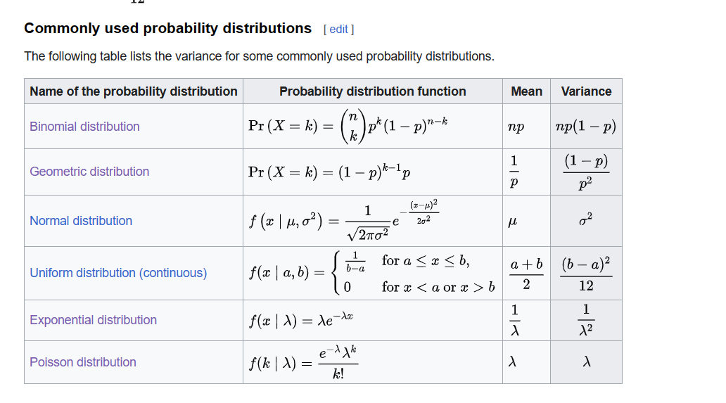

Ref

For all properties and some proof, see Wiki:

[Exponential distribution - Wikipedia](https://en.wikipedia.org/wiki/Exponential_distribution)

For more proof, see statlect:

[Geometric distribution | Properties, proofs, exercises (statlect.com)](https://www.statlect.com/probability-distributions/geometric-distribution)